**Apply to Be A Community Outreach Volunteer**

The City of Fort Bragg, Noyo Harbor District and California Sea Grant have partnered to develop the Noyo Harbor Blue Economy Visioning, Resiliency and Implementation Plan ([**The Plan**](https://noyooceancollective.org/the-plan/)). This 2-year planning process will provide comprehensive baseline information about the existing environmental, physical, social and economic conditions of Noyo Harbor to support informed decision making. It will also provide a process by which a shared community vision for a climate resilient Noyo Harbor is identified. Help bring all perspectives into the conversation and apply to be an Outreach Volunteer today!

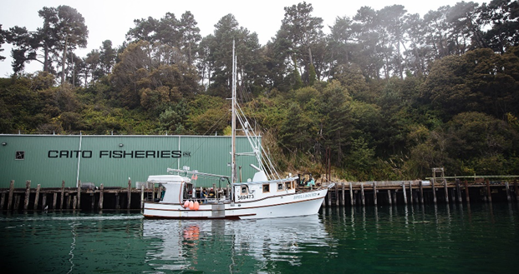

**What does the Community Outreach Team do?**

The Community Outreach Team shares information about how to get involved with the Noyo Harbor Blue Economy Visioning, Resiliency and Implementation Plan, and subsequent update to our Local Coastal Program.

Outreach Volunteers help coordinate and host outreach events, distribute surveys, share resources (e.g., the Noyo Ocean Collective website [www.NoyoOceanCollective.org], social media posts, flyers and postcards, and news releases), answer frequently asked questions, and serve as liaisons between the Planning Team and community. The Planning Team consists of representatives from the City of Fort Bragg, Noyo Harbor District, Noyo Ocean Collective, and California Sea Grant. Members of the Outreach Team will be in direct contact with a member of the Planning Team.

**Why me?**

Why not?! We want to engage every segment of community, with specific focus on identifying environmental justice communities that have historically been left out of the decision making process. Our goal is to ensure techniques for outreach are crafted in collaboration with environmental justice communities and/or organizations in order to remove barriers for participation.

**Why do I need to apply?**

There are limited resources, and we want to make sure this opportunity is made available to a broad range of people and interests, so we are implementing an application process. The Outreach Team will be provided training, on-going mentorship and a stipend to offset expenses.

**What will the selection process look like?**

Applications will be reviewed by a panel comprised of the Planning Team, and individuals will be contacted to discuss details, respond to questions, and confirm interest. A training is tentatively scheduled for the first week in December.

**What information is requested in the application?**

Contact information, general availability, local organizations you’re affiliated with, and some details about your interest. Prior experience is not required.

Completed application can be emailed to: [CityFB@NoyoOceanCollective.org](mailto:CityFB@NoyoOceanCollective.org) or delivered to: City of Fort Bragg, located at 416 N Franklin Street, Fort Bragg, CA 95437.

**Community Outreach Team Application**

Noyo Harbor Blue Economy Visioning, Resiliency and Implementation Plan + Local Coastal Program Updates

Name: __________________________________________________________________________________________

Email: __________________________________________ Phone: _________________________________

Mailing Address: ____________________________________________________________________________

Outreach activities will be scheduled throughout the week. Please let us know if there are days and times you are generally **NOT AVAILABLE**. Individual events will be scheduled in advance and availability confirmed prior to each event.

|  |  |  |  |  |
| --- | --- | --- | --- | --- |
| **Day** | **8am-11am** | **11am-2pm** | **2pm-5pm** | **5pm-8pm** |
| Monday |  |  |  |  |
| Tuesday |  |  |  |  |
| Wednesday |  |  |  |  |
| Thursday |  |  |  |  |
| Friday |  |  |  |  |
| Saturday |  |  |  |  |
| Sunday |  |  |  |  |

Do you work for, volunteer with, or receive services from local community based organizations?

Tell us about it!

__________________________________________________________________________________________

_________________________________________________________________________________________

_________________________________________________________________________________________

Which languages do you speak? ______________________________________________________________

Do you have access to reliable transportation? ___ yes ____ no

If not, that’s ok! Would you be interested in carpool/ride share? _____ yes _____ no

Do you need childcare? _____ yes _____ no _____ occasionally

Why do you want to join the Community Outreach Team?

__________________________________________________________________________________________________

__________________________________________________________________________________________________

_________________________________________________________________________________________________

_________________________________________________________________________________________________

_________________________________________________________________________________________________

__________________________________________________________________________________________________

_________________________________________________________________________________________________

Is there a community member that you would recommend for the Outreach Team?

Name: ____________________________________________________________________________________

Organization: _____________________________________________________________________________________

Anything else you want to tell us?

__________________________________________________________________________________________________

__________________________________________________________________________________________________

__________________________________________________________________________________________________

__________________________________________________________________________________________________

__________________________________________________________________________________________________

__________________________________________________________________________________________________

__________________________________________________________________________________________________

__________________________________________________________________________________________________

Thank you for your interest!

We will use the contact information provided and follow-up during the month of November.

Training is tentatively scheduled the first week of December.